Project 1

Team Six

Team Leader: Jason Smith

Mohammed Al Ofi

Bryan Franklin

**A UML class diagram**

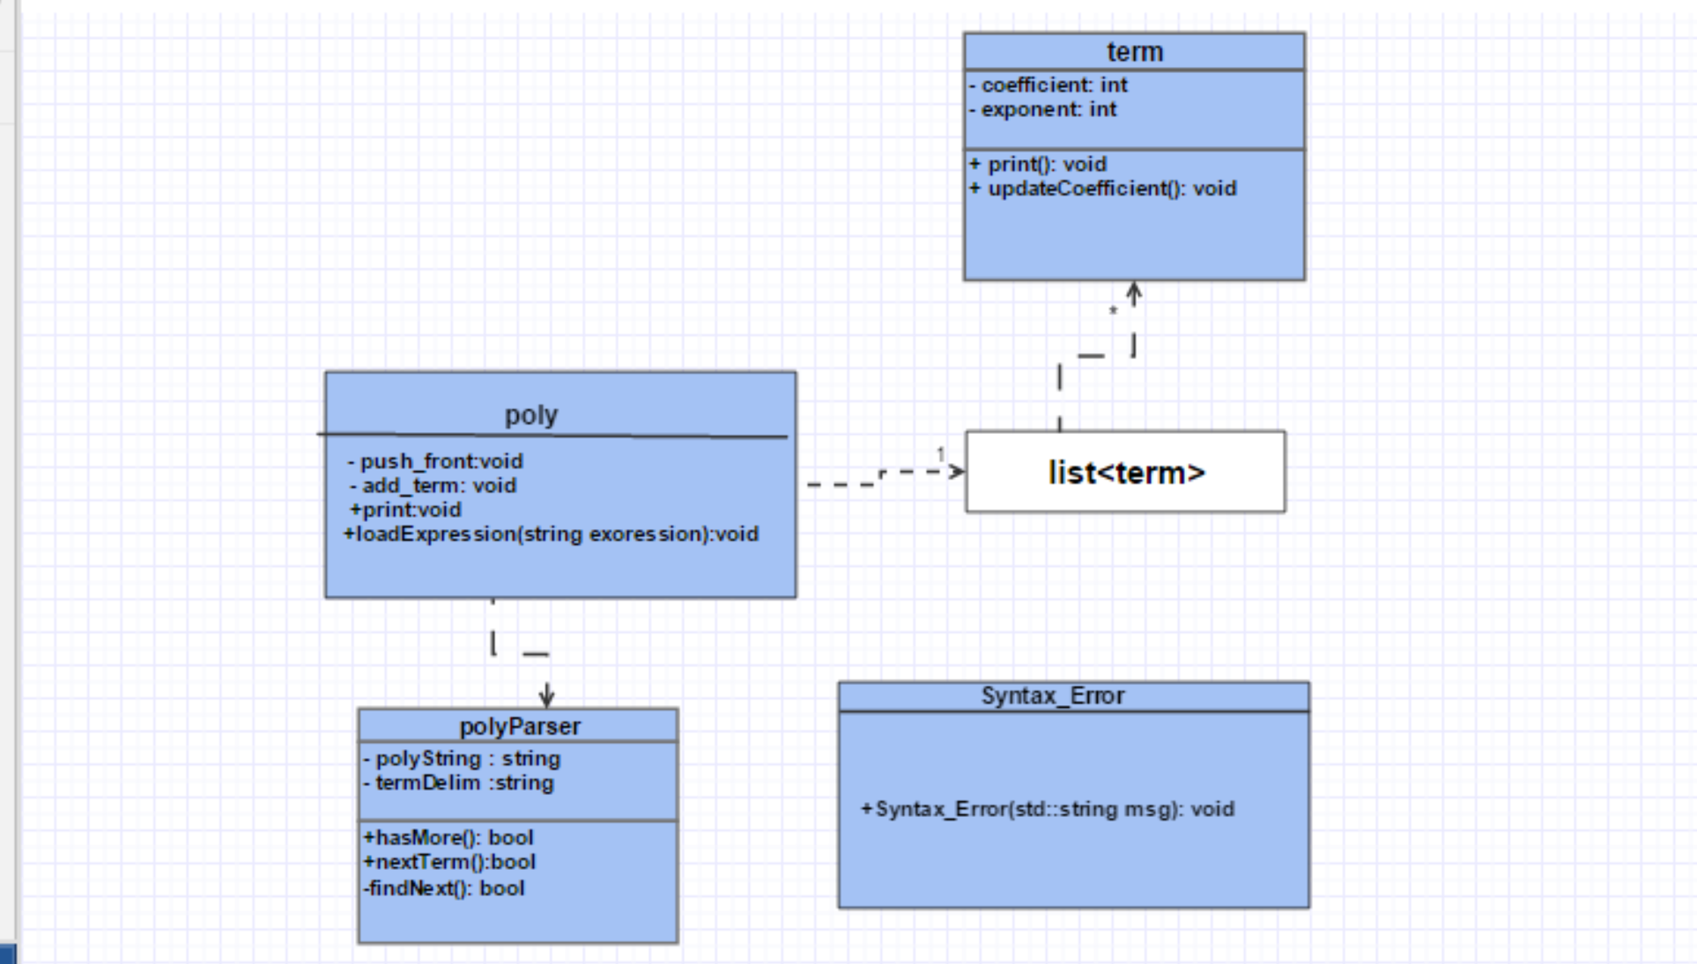

GitHub:

<https://github.com/jhsz72/Project1B>

**Efficiency of Algorithms**